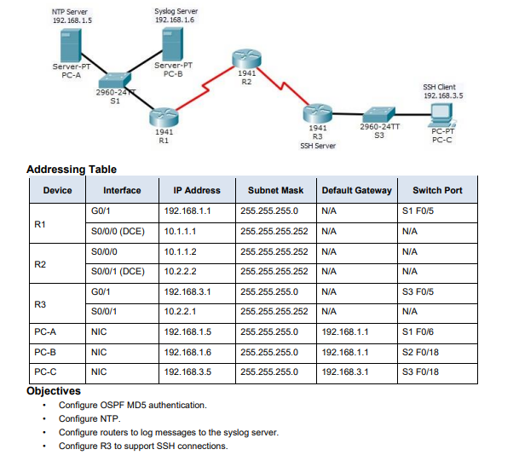

Router 1
Ip:
Router>en
Router#conf t
Enter configuration commands, one per line. End with CNTL/Z.
Router(config)#clock timezone IST 5 30
interface g0/1
ip address 192.168.1.1 255.255.255.0
no shutdown
interface s0/0/0
ip address 10.1.1.1 255.255.255.252
clock rate 64000
no shutdown
odpf md5:
Router(config)#router ospf 1
Router(config-router)#network 192.168.1.0 0.0.0.255 area 0
Router(config-router)#network 10.1.1.1 0.0.0.3 area 0
Router(config-router)#interface s0/0/0
Router(config-if)#ip ospf authentication message-digest
Router(config-if)#ip ospf message-digest-key 1 md5 cisco
Router(config-if)#ex
Ntp:
Router(config)#ntp server 192.168.1.5
Router(config)#ntp update-calendar
Syslog:
Router(config)#service timestamps log datetime msec
Router(config)#service timestamps debug datetime msec
Router(config)#logging 192.168.1.6
Router(config)#logging trap debugging
Router(config)#

Router 2
Ip:
Router>en
Router#conf t
Enter configuration commands, one per line. End with CNTL/Z.
Router(config)#clock timezone IST 5 30
interface s0/0/0
ip address 10.1.1.2 255.255.255.252
no shutdown

interface s0/0/1
ip address 10.2.2.2 255.255.255.252
clock rate 64000
no shutdown
ospf md5:
Router(config)#router ospf 1
Router(config-router)#network 10.1.1.0 0.0.0.3 area 0
Router(config-router)#network 10.2.2.0 0.0.0.3 area 0
Router(config-router)#ex
Router(config)#interface se0/0/0
Router(config-if)#ip ospf authentication message-digest
Router(config-if)#ip ospf message-digest-key 1 md5 cisco
Router(config-if)#ex
Router(config)#interface se0/0/1
Router(config-if)#ip ospf authentication message-digest
Router(config-if)#ip ospf message-digest-key 1 md5 cisco
Router(config-if)#ex
Ntp:
Router(config)#ntp server 192.168.1.5
Router(config)#ntp update-calendar
Syslog:
Router(config)#service timestamps log datetime msec
Router(config)#service timestamps debug datetime msec
Router(config)#logging 192.168.1.6
Router(config)#logging trap debugging
Router(config)#

Router3
Ip:
Router>en
Router#conf t
Enter configuration commands, one per line. End with CNTL/Z.
Router(config)#clock timezone IST 5 30
interface g0/1
ip address 192.168.3.1 255.255.255.0
no shutdown

interface s0/0/1
ip address 10.2.2.1 255.255.255.252
no shutdown
ospf md5:
Router(config)#router ospf 1
Router(config-router)#network 192.168.3.0 0.0.0.255 area 0
Router(config-router)#network 10.2.2.0 0.0.0.3 area 0
Router(config-router)#ex
Router(config)#interface s0/0/1
Router(config-if)#ip ospf authentication message-digest
Router(config-if)#ip ospf message-digest-key 1 md5 cisco
Ssh:
Router(config-if)#ip domain-name cisco.com
Router(config)#
Router(config)#username admin privilege 15 secret cisco
Router(config)#
Router(config)#crypto key generate rsa
Router(config)#ip ssh version 2
Please create RSA keys (of at least 768 bits size) to enable SSH v2.
Router(config)#
Router(config)#line vty 0 4
Router(config-line)#login local
Router(config-line)#transport input ssh
Router(config-line)#exit
Ntp:
Router(config)#ntp server 192.168.1.5
Router(config)#ntp update-calendar
Syslog:
Router(config)#service timestamps log datetime msec
Router(config)#service timestamps debug datetime msec
Router(config)#
Router(config)#logging 192.168.1.6
Router(config)#logging trap debugging
Router(config)#

Command to check:
show ntp status
show clock
show logging

